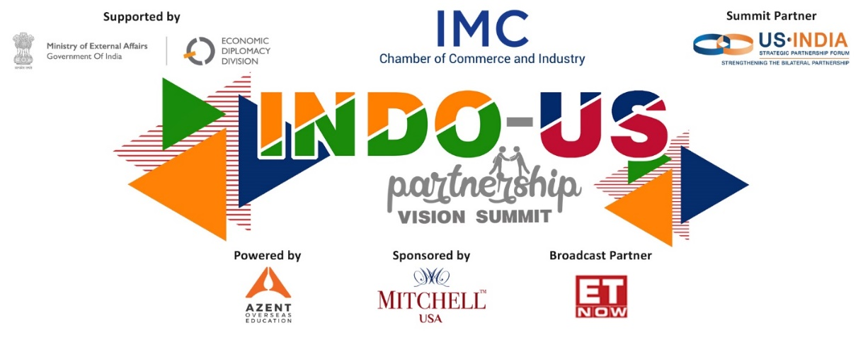

Dates & Timings | DAY 1- Thursday, 29th April 2021 | 5:30 p.m. - 9:15 p.m. (IST)
 | DAY 2- Friday, 30th April 2021 | 6:00 p.m. - 9:00 p.m. (IST)

TENTATIVE PROGRAM SCHEDULE
DAY 1- Thursday, 29th April 2021 | 5:30 p.m. - 9:15 p.m. (IST)
Timings (IST) | Agenda
5.30 pm – 6.15 pm | SESSION I: Importance and Future of Health  Welcome Remarks  - Mr. Ajit Mangrulkar, Director General, IMC Chamber of Commerce and Industry  Opening Remarks  - Guest of Honor: Lieutenant Governor Ms. Bethany Hall-Long, State of Delaware  Panel Discussion  - Ms. Kate Beale, Associate Vice President for International Advocacy Pharmaceutical Research and Manufacturers of America, PhRMA  - Dr. Murtaza Khorakiwala, Managing Director, Wockhardt Limited  - Mr. Yugal Sikri, Managing Director, RPG Life Sciences Limited  Moderator: Mr. Atul Joshi, Founder & CEO, Oyster Capital Management

6.15 pm – 7.00 pm | SESSION II: Regional Bilateral Co-operation  Opening Remarks  - Mr. Lutfi Hassan, Chairman & CEO, Apex Group of Companies, USA  Guest of Honour Special Address  - Hon’ble Mr. Vijay Rupani, Chief Minister of Gujarat  Panel Discussion  - Hon. Mr. Geoffrey Connor, Former Texas Secretary of State  - Mr. Arun M. Kumar, Chairman and CEO, KPMG  - Mr. Paresh (Perry) Patel, Executive Director of Lotus Recovery Centers, USA  Moderator: Mr. Rahul Sharma, Managing Director, APCO Worldwide
7.00 pm – 7.45 pm | SESSION III: Trends in Emerging Tech  Panel Discussion  - Mr. Nitin Rakesh, Chief Executive Officer, Mphasis  - Dr. Ruchi Dana, Managing Director, Dana Group, Dubai  - Mr. Suresh Sethi, Managing Director and Chief Executive Officer, NSDL e-Governance Infrastructure Limited  - Mr. Tadepalli Rao, CIO, Seibels Insurance Services, USA  Moderator: Ms Susan Ritchie, Vice President of Trade and Technology Policy, US India Strategic Partnership Forum
7.45 pm -8.30 pm | INAUGURAL SESSION  Indo-US Partnership Vision  Welcome Address  - Mr. Rajiv Podar, President, IMC Chamber of Commerce and Industry  Chief Guest  Hon’ble Shri Jayant Sinha, Chairperson, Parliamentary Standing Committee for Finance, Member of Parliament  Q & A Moderator: Mr. Atul Nishar, Founder and Chairman, Azent Overseas Education Private Limited, Founder & Chairman Emeritus, Hexaware Technologies Limited  Vote of Thanks  - Mr. Juzar Khorakiwala, Vice President, IMC Chamber of Commerce and Industry
8.30 pm – 9.15 pm | SESSION IV: Entertainment (Hollywood/Bollywood)  Panel Discussion  - Mr. Jack Giarraputo, American film producer & co-founder Happy Madison Productions  - Mr. Madhur Bhandarkar, Acclaimed Award Winning Filmmaker  - Ms. Mary Millben, Award Winning Hollywood Actress/Singer  - Mr. Jason Hafford, Agent Creative Artists Agency (CAA)  Moderators  - Ms. Medha Jaishankar, Senior Producer at JetSynthesys  - Ms. Priya Samant, Impact Advisor & Director Sequoia Applied Technologies
Vote of Thanks for the day

Ms. Sunita Ramnathkar, Director, Eudora Enterprises Limited, Mitchell Group USA

DAY 2 Program on next page below

DAY 2- Friday, 30th April 2021 | 6:00 p.m. - 9:00 p.m. (IST)
Timings (IST) | Agenda
6.00 pm – 7.00 pm  6.00 pm-6.03 pm  6.03 pm-6.10 pm  6.10 pm-6.30 pm  6.30 pm-6.55pm  6.55 pm-7.00 pm | INAUGURAL SESSION: A New Era of Indo-US Relations  Welcome Address  - Mr. Rajiv Podar, President, IMC Chamber of Commerce and Industry  Opening Remarks  - Mr. Swadesh Chatterjee, Chairman and Co-Founder, US India Friendship Council  Keynote Address by  Chief Guest Hon’ble Shri Nitin Gadkari ji, Union Minister of Road Transport and Highways, Micro, Small & Medium Enterprises  Discussion  - Chief Guest: Hon’ble Shri Nitin Gadkari ji, Union Minister of Road Transport and Highways, Micro, Small & Medium Enterprises  - Mr. Rajesh Subramaniam, President and Chief Operating Officer of FedEx Corporation  Moderator: Dr. Mukesh Aghi, President & CEO, US-India Strategic Partnership Forum  Closing Remarks and Vote of Thanks  Dr. Mukesh Aghi, President & CEO, US-India Strategic Partnership Forum
7.00 pm – 7.30 pm | SESSION V: Finance & Investments  Panel Discussion  - Mr. Jaspal Bindra, Chairman, Centrum Group of Companies  - Ms. Kaku Nakhate, President and Country Head (India), Bank of America N.A.  - Mr. Sanjay Nayyar, Chairman, KKR India  Moderator: Mr. Malachy Nugent, Vice President, Financial Services, USISPF
7.30 pm – 8.00 pm | SESSION VI: Defence/Homeland Security  Panel Discussion  - Mr Ravi Nirgudkar, Managing Director, BAE Systems, India  - Mr Salil Gupte, President, Boeing India  Moderator: Mr. S P Shukla, Chairman, Mahindra Defence, Mahindra Aerospace, Mahindra Sanyo Steel, Mahindra CIE Automotive Ltd, etc.
8.00 pm – 8.30 pm | SESSION VII: Knowledge Economy (Education & Skill Across Boundaries)  Panel Discussion  - Dr. Suhas Pednekar, Vice Chancellor, University of Mumbai  - Ms. Anjali Raina, Executive Director, Harvard Business School India Research Centre  Moderator: Mr. Samir Somaiya, Chairman, K J Somaiya, Education Trusts, Chairman & Managing Director, Godavari Biofineries Limited
8.30 pm – 9.00 pm | VALEDICTORY SESSION  Guests of Honour  - H.E. Mr. Taranjit Singh Sandhu, Ambassador of India to United States, Embassy of India  - H.E. Ambassador Mr. Timothy Roemer, Executive Director and Strategic Counselor at APCO Worldwide  Moderator: Mr. Richard M. Rossow, Wadhwani Chair in U.S. India Policy Studies, The Center for Strategic and International Studies
Vote of Thanks
- Mr. Dinesh Joshi, Chairman, IMC International Business Committee

