CIRCULAR

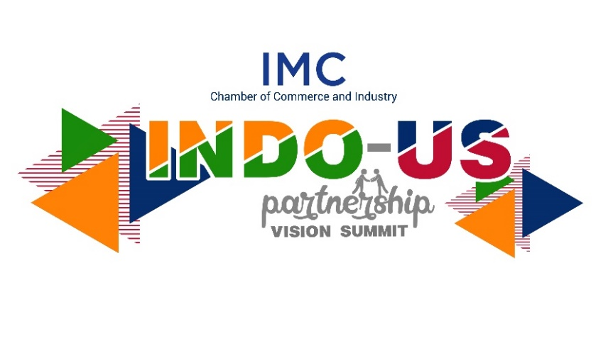
Dates & Timings:
DAY 1- Thursday, 29th April 2021 | 5:30 pm - 9:15 pm (IST)
DAY 2- Friday, 30th April 2021 | 6:00 pm - 9:00 pm (IST)

Dear Sir/ Madam,

We are pleased to inform you that IMC Chamber of Commerce and Industry is organizing a virtual Indo-US Partnership Vision Summit on Thursday, 29 April 2021 and Friday, 30 April 2021.

We are happy to inform that Hon. Shri Nitin Gadkari, Union Minister for Road Transport and Highways and Hon. Shri Vijay Rupani, Chief Minister of Gujarat have confirmed their participation and the Economic Diplomacy Division of Ministry of External Affairs of Government of India has extended official support to the Summit aimed at building a robust relationship between India and US. This is apart from a galaxy of leaders from politics, business and industry from India and the US will participate during the 2-day summit.

There was no better time in past than the current one that required further expanding and strengthening bilateral relationship between US and India. India-US bilateral coordination flows from shared values, and commitment to democracy and peace. The last two decades have seen partnership growing into more areas of cooperation, making it more broad, complex and rich in substance. We cooperate in defence, counterterrorism, cybersecurity, health, environment, agriculture, technology, and in many more areas. In the last few years, our bilateral has become more dynamic with signing of crucial defence agreements. Our economic relations have also seen progress. The US-India bilateral trade in goods and services in last two decades has grown to over $146 billion in 2019. However, it has not progressed in the same way the strategic engagements have grown. The evolving geopolitical situation for both US and India, and emerging challenges and opportunities due to shifting global supply chain resulting from the COVID pandemic has made it all the more imperative for US and India to join forces to scale up economic and strategic engagement to unprecedented level in order to preserve and expand peace and prosperity. For this to happen, coordinated efforts are required between governments and private sectors in both countries.

It is in this context that IMC is organizing Indo-US Summit, a virtual gathering of influential leaders and decision makers to interact and chart a roadmap for achieving robust relationship based on mutual trust, respect and complementarity.

The objective of the Indo-US Partnership Summit is to bring together influential leaders and decision makers to interact and chart a roadmap for building a robust relationship based on mutual trust, respect and complimentary.

Apart from discussions on geopolitics and overall opportunities, the Summit will focus specifically on potential possibilities in areas of Education, Finance and Investment, Health (infra, biotech, life science, Pharma), Trends in Emerging Techs, Defence, Cyber security and Entertainment.

We take great pleasure in inviting you to attend the Summit on Thursday, 29th April 2021 from 5:30 pm - 9:15 pm (IST) and Friday, 30th April 2021 from 6:00 pm - 9:00 pm (IST).

To confirm your participation, you may register online on https://www.imcnet.org/events-1006

Kindly note there is NO PARTICIPATION FEE but prior registration is mandatory. We will send access link once you register.

We look forward to your participation.

With regards,

Ajit Mangrulkar
Director General

