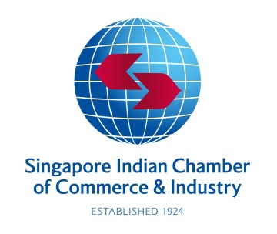

INTERACTIVE MEETING

‘Emerging Business Opportunities between India and Singapore post-Covid’

Date: Thursday, April 08, 2021 | Time: 2.00 pm – 3.30 pm IST/ 4.30 pm -6.00 pm SGT

Timings | Agenda
2.00 pm – 2.05 pm (IST)  4.30 pm – 4.35 pm (SGT)  2.05 pm – 2.10 pm (IST)  4.35 pm – 4.40 pm (SGT)  2.10 pm – 2.15 pm (IST)  4.40 pm – 4.45 pm (SGT) | Welcome Remarks  - Mr. Rajiv Podar, President, IMC Chamber of Commerce and Industry  - Dr. T. Chandroo, Chairman, Singapore Indian Chamber of Commerce & Industry  Opening Remarks  - Ms. Aarti Chandaria, Singapore Representative of IMC Chamber of Commerce and Industry
2.15 pm – 2.30 pm (IST)  4.45pm – 5.00 pm (SGT)  2.30 pm – 2.45 pm (IST)  5.00 pm – 5.15 pm (SGT) | Keynote Address  - H.E. Mr. P. Kumaran, High Commissioner of India, Singapore  Special Address  - Honourable Mr. Vikram Nair, Member of Parliament, Republic of Singapore
2.45 pm – 3.25 pm (IST)  5.15 pm – 5.55 pm (SGT) | Panel Discussion  - Mr. K. V. Rao, Resident Director ASEAN, Tata Sons, Singapore  - Mr. Sriram Chakravarthi, Counsel - Funds & Investment Management, Rajah & Tann Singapore LLP  - Mr. Manish Kejriwal, Managing Partner, Kedaara Capital
3.25 pm – 3.30 pm (IST)  5.55 pm – 6.00 pm (SGT) | Closing Remarks & Vote of Thanks  - Mr. Juzar Khorakiwala, Vice President, IMC Chamber of Commerce and Industry
Moderator for the event:
Ms Shobha Tsering Bhalla, Board Director of Singapore Indian Chamber of Commerce & Industry and Managing Director, India Se Media

