Mr. Vishwas Nangare Patil (IPS)
Joint Commissioner of Police, Law and Order
Mumbai.

Respected Mr. Patil,

Greetings from the Ladies’ Wing of IMC Chamber of Commerce and Industry!

This is in reference to your conversation with Mr. Badal Mittal, wherein you had kindly consented to support our endeavour of making Mumbai a Safer City for Women and Children.

Being the veteran chamber in Mumbai, the intent of the IMC Ladies’ Wing has always been to act as an incorrigible force for social change and gender parity. Over the years, our members have actively strengthened the bulwark of social justice and equality for all through various social service initiatives. The Wing regularly works with various corporates, social organisations and NGOs in the fields of women empowerment, livelihood intervention, educational development and healthcare.

IMC Ladies’ Wing has been planning to launch the project “Make Mumbai Safe” to create awareness and sensitization for women and children regarding their safety and protection.

We are glad to inform you that we have been spiritedly working towards this initiative and are ready with a proposed course of action. We therefore would request you to kindly give us a date feasible to yourself for the meeting through Zoom Video Conferencing.

We shall be truly grateful to take our initiative ahead with you.
Looking forward to hearing from you.

Yours sincerely,
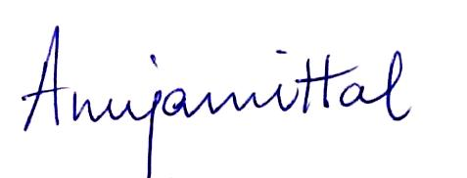
Anuja Mittal Bharti Gandhi
President Chairperson
IMC Ladies’ Wing Make Mumbai Safe Committee

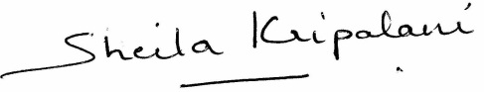
Sheila Kripalani Reena Rupani
Co-Chairperson Co-Chairperson
Make Mumbai Safe Committee Make Mumbai Safe Committee

About Ladies’ Wing of IMC Chamber of Commerce and Industry:
The IMC Chamber of Commerce and Industry is one of the leading Chambers of Commerce & Industry in India. It is the only Trade and Commerce organization, which has had the unique privilege of having Mahatma Gandhi - Father of our Nation, as its Honorary Member.
The Ladies' Wing of IMC Chamber of Commerce and Industry, which started as a forum for social awareness in 1966, is a premier women's organization. It is a dynamic movement for the empowerment of the Indian woman and caters to women's causes through education, entrepreneurship and economic upliftment. The role of women, from setting up and managing a home to having a successful career, has undergone a metamorphosis. The Ladies’ Wing is a true reflection of women’s changing status in the business world.
The Wing has a membership of almost 2500 women comprising entrepreneurs, professionals, social activists and homemakers. Some of our activities include facilitating panel discussions with eminent speakers, hosting a variety of educational programs and workshops, organizing business delegations and exhibitions to support the entrepreneurial potential of women, and creating a platform for women achievers to share their success stories as an inspiration to others.

