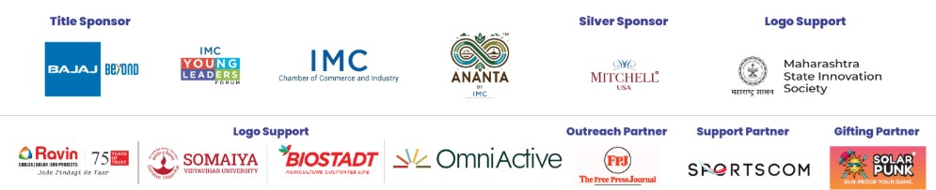


The Young Leaders Forum (YLF)

of The IMC Chamber Of Commerce and Industry

Presents
Yuva Kshamata - Sports Conclave
Date & Venue: January 22, 2026 at Taj Lands End, Bandra, Mumbai
Timing: 10.00 am to 06:30 pm

Concept Note

The Young Leaders’ Forum (YLF) of the IMC Chamber of Commerce and Industry (IMC), under the banner Ananta by IMC, is organising the fifth edition of its annual flagship Youth Conclave, titled ‘Yuva Kshamata – Sports Conclave’.


The one-day Conclave will bring together Athletes and para-athletes, sports federations and academies, start-up and sports-tech innovators, corporate leaders, educators, youth representatives, International dignitaries and diplomatic representatives—to ignite dialogue, inspire action, and shape the future of sports in India.

This year, the theme for ‘Yuva Kshamata – Sports Conclave’ embodies the vision of harnessing the transformative power of sports as a catalyst for holistic national development. The Conclave seeks to align with the objectives of the National Sports Policy (NSP) 2025 and the vision of Hon’ble Prime Minister, Shri Narendra Modi ji. Schemes like Khelo India are fueling the transformation aimed at building a stronger talent pipeline and improving overall sporting governance with the goal of placing India in the top 10 globally by 2035.

India’s engagement with a commonwealth games has significantly evolved as a global soft power. The recent awarding of the 2030 Commonwealth Games marks a new era in this outlook.

Over the previous editions, the Youth Conclave has raised a dialogue on critical subjects such as education, youth and skill development, sustainability and climate change, promoting start-ups culture in India. The Conclave has served as a dynamic platform, bringing together students, young professionals, industry leaders, corporate stalwarts, Government officials, Consulates and Ministry representatives from across India and abroad. Across its enriching past editions, the Conclave has reached over 10,000 participants, including young entrepreneurs, policymakers, industry leaders, and students from more than 75 institutions across India and abroad.

As part of this year’s Conclave, a special segment of Student Competition will be hosted after each panel discussion, bringing together college participants from India and abroad. Students will present their perspectives and innovative ideas on the respective theme of the panel that they have been selected for. Through this initiative, the Conclave continues its commitment to empowering young voices and fostering national and international collaboration

This Sports Conclave is anchored on following panels:

- Sports Psychology: Health, Nutrition and Mental Fitness: Fuelling the Champions through holistic well-being - Peak athletic performance depends not only on physical ability but also on mental strength, balanced nutrition, and holistic well-being. This panel will explore the critical role of sports psychology and integrated health practices in nurturing resilient, focused, and high-performing athletes. Discussions will cover mental conditioning, stress management, recovery, and the importance of tailored nutrition in enhancing performance and preventing burnout. Experts and practitioners will share insights into creating supportive ecosystems that prioritize athlete welfare, helping them sustain excellence both on and off the field. The session aims to highlight how a holistic approach to mind and body can truly fuel champions.

- Education and Careers in Sports — The Game Beyond the Game: The business of sport has evolved into one of the world’s most dynamic and interdisciplinary industries. Beyond athletes and arenas lies a thriving ecosystem of professionals driving performance, data, finance, technology, and fan experience. Careers in sport now span analytics, AI, marketing, management, law, entrepreneurship, and content creation. The rise of sport-tech, digital platforms, and AI-driven performance tools is redefining what it means to work in sport. This panel explores how young professionals and entrepreneurs can convert their passion for sport into a sustainable career path. It highlights emerging opportunities across management, innovation, and business operations in the sports economy. Experts will decode how finance, governance, and technology are shaping the next generation of roles. The discussion bridges purpose and profit — inspiring talent to build meaningful, future-ready careers in sport. It showcases the intersection of data, design, and decision-making that fuels the modern sports ecosystem. Ultimately, it invites the next generation to play their part — not just on the field, but in the boardrooms, labs, and digital arenas shaping the future of sport.

- AI and Start-up Revolution and the Business of Sports: How artificial intelligence and start-ups are transforming the future of sports - Artificial intelligence and sports-tech start-ups are reshaping the way sports are played, managed, and experienced. This panel will delve into how emerging technologies—ranging from data analytics and performance tracking to fan engagement, injury prevention, and talent scouting—are driving innovation across the sports ecosystem. It will highlight success stories of start-ups leveraging AI to solve real-world challenges, as well as the opportunities and ethical considerations that come with digital transformation. The discussion aims to showcase how collaboration between technology innovators, sports organizations, and investors can unlock new efficiencies, insights, and business models, ultimately redefining the future of sports.

- Roots & Reboots: New Age Sports and the Revival of Traditional Indian Games: Exploring the rise of modern sports opportunities and reigniting interest in India’s rich heritage of traditional games - As modern sports gain global traction, there is a growing movement to reconnect with India’s rich heritage of traditional games that once formed the backbone of community life and physical culture. This panel will explore how traditional Indian sports are being revived and reimagined in contemporary contexts—through grassroots initiatives, digital storytelling, and institutional support—alongside the rise of new-age disciplines and opportunities. The discussion will highlight the balance between preserving cultural identity and embracing innovation, examining how both traditional and emerging sports can coexist to inspire participation, pride, and inclusivity across generations.

Fireside Chat by
- Mr. Liam Botham, a Multi-Sport Athlete with Mr. Vedant Podar, Member, IMC Young Leaders Forum and CEO & Co-founder, Podar Eduspace
Ice Breaker Sessions: Beyond Limits
- Inspirational Video Address by Ms. Revathi Devasthale, International Badminton Athlete (World Rank #81), Law Gold Medalist and Real Estate Professional @ Cushman & Wakefield.

