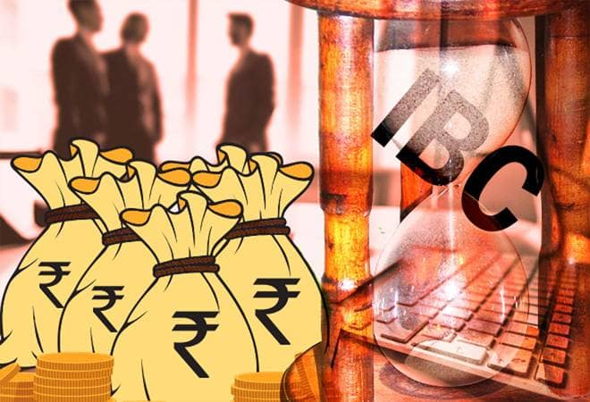

Date: August 23, 2019 Time: 4.30 pm -8.00pm

IMC Chamber of Commerce and Industry along with IP Foundation are organizing a Workshop on Important Aspects on Insolvency and Bankruptcy Code (IBC).

Overview
Insolvency and Bankruptcy Code 2016, has been a most evolving laws in present time. The code emphasis on resolving the issues of an entrepreneur, where by his wrong decision or wrong timing or due to economy cycle his business is not visible or he himself may not be able to turnaround his venture. The code by way of resolution plan by an resolution applicant intend to give a chance to ailing industry to turnaround with the assistance of an turnaround expert i.e insolvency professional. The workshop intends to guide participants on Understanding of Resolution plan with Evaluation Matrix and RFRP document.

Who Can Participate
CA, CS, COST ACCOUNTANTS, INSOLVENCY PROFESSIONAL, CFO, CLO, ADVOCATES.

Benefits to participants
- Detail understand on various perspective of resolution plan
- Assist them in preparation of plan
- Assist to have effective Merger and acquisition structure under Insolvency and Bankruptcy Code.

REGISTRATION
Venue: Kilachand Conference Room, 2nd Floor IMC, Churchgate 400200
Online Payment link: https://imjo.in/CWYUwV
Contact No-022- 71226685/98693 51460

We cordially invite you to attend this workshop. The fees of the workshop would be: Rs.1500/-. Registration is mandatory due to limited number of seats. We will appreciate a line in confirmation of your participation with your name/company/contact details.

We look forward to your participation.

Ajit Mangrulkar
Director General,
IMC Chamber of Commerce and Industry

Program Schedule

4.30 to 5.00 pm | Registration and Networking
5.30 to 7.30 pm | Panel  - Adv. Anandaday Mishra  Founder, AMLEGAL  - Mr. Sanjeev Pandey  DGM (NCLT), State Bank of India  - CA Snehal Kamdar
7.30 to 8.00pm | Q& A followed with Concluding Remarks

