Panel Discussion on 'Challenges facing the MSME Sector
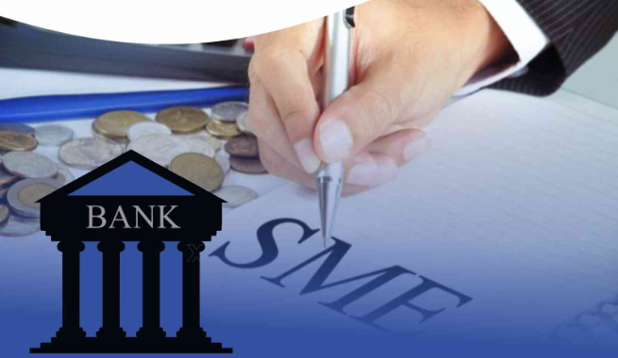
Date: OCTOBER 10, 2019 Time: 3.00 pm -6.00pm

IMC Chamber of Commerce and Industry and Business Standard have joined hands to organise a series of events - panel discussions, seminars and the like - to deliberate issues facing the economy, trade, commerce and industry and seek to explore practical solutions that would energise business as also provide policy inputs for the government.

First in the IMC-Business Standard series is a Panel Discussion on 'Challenges facing the MSME Sector' scheduled for October 10, 2019 at 3.00 pm at Babubhai Chinai Committee Room, 2nd Floor, IMC Churchgate, Mumbai 400020.

The Micro, Small and Medium Enterprises (MSMEs) are a vital and integral part of the country’s economic structure. There are an estimated 63 million such units that contribute to thriving economic activity, create jobs, generate incomes and participate in exports to earn valuable foreign exchange. Importantly, MSMEs help unleash the entrepreneurial spirit and foster innovation through investments. So, it is critical to support the growth and development of the MSME sector.

The panel discussion is expected to cover several dimensions of business including finance, technology infusion, skill development, innovation and business promotion. The panelists will comprise sector specialists including two MSME entrepreneurs, a banker and a State government official. The discussion will be moderated by a BS representative.

Based on the conclusions of the Panel Discussion, IMC would consider making recommendations to policymakers.

We cordially invite you to attend this panel discussion. Please send your confirmation to Ms. Anita Naik at anita.naik@imcnet.org or Phone: Tel.: 022 71226686.

Kindly note there is no registration fee, but registration is mandatory due to limited number of seats. We look forward to your participation.

Ajit Mangrulkar
Director General,
IMC Chamber of Commerce and Industry

