31st December, 2019

Mr. Prasoon Joshi
Chairman, McCann Worldgroup, Asia Pacific
CEO & CCO McCann Worldgroup, India

Dear Mr. Joshi,
Greetings from Ladies' Wing of IMC Chamber of Commerce and Industry!
On behalf of the Ladies’ Wing, we would like to thank you for accepting our invitation to be the Chief Guest for the 27th IMC Ladies’ Wing Jankidevi Bajaj Puraskar 2019 to be held on Tuesday, 7th January 2020 at 3.30 pm at Walchand Hirachand Hall, 4th floor, IMC, Churchgate, Mumbai.

Your esteemed presence will further elevate the stature of the puraskar.
An interactive meeting is convened from 3:30 pm to 3:55 pm at H.T. Parekh Conference Room on 7th January, 2020 with the awardee and the Chief Guest. After which, the function commences at 4:00 pm.
You are kindly requested to deliver a keynote address on the topic – “Why Indian women conquer against all odds, (Shakti Swarup)” at the function.
Looking forward to welcoming you at the event.
Please find enclosed herewith the invitation card and the programme flow for your kind perusal.
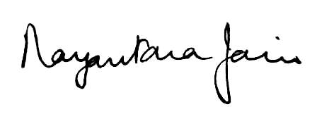
Vanita Bhandari Nayantara Jain
President Chairperson
IMC Ladies’ Wing JBP Committee 2019

