17th July, 2019

Ms. Irma Chinai

Past President

IMC Ladies’ Wing

Dear Ms. Chinai,

**Greetings from Ladies’ Wing of IMC Chamber of Commerce and Industry**

On behalf of the IMC Ladies’ Wing we express our heartfelt gratitude to you for providing your continuing and unstinting support to promote IMC Ladies’ Wing events through striking display in highly coveted newspaper Janmabhoomi.

This year, we request your support in promoting the nomination process of the Jankidevi Bajaj Puraskar 2019 through coverage in Janmabhoomi.

We value your association for promoting the cause of women entrepreneurship and empowerment by encouraging our endeavour.

Please find enclosed herewith the pendrive with the artwork for your kind perusal.

Thanking You.

Warm Regards,

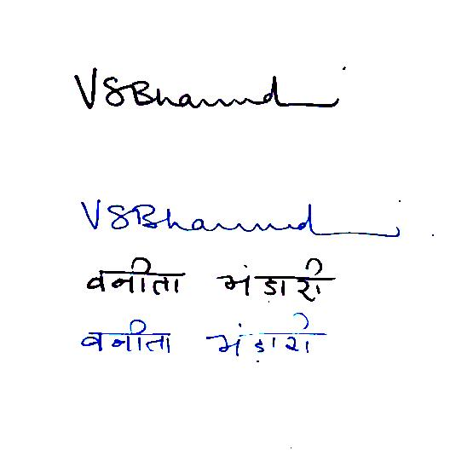 

Vanita Bhandari Nayantara Jain

President Chairperson

IMC Ladies’ Wing JBP Committee 2019