8th January, 2020

Mr. Prasoon Joshi
Chairman, McCann Worldgroup, Asia Pacific
CEO & CCO McCann Worldgroup, India

Dear Mr. Joshi,
Greetings from Ladies' Wing of IMC Chamber of Commerce and Industry!
It was an honour having you amidst us as our respected Chief Guest for the 27th IMC Ladies’ Wing Jankidevi Bajaj Puraskar 2019 function held on the 7th January 2020 at IMC, Mumbai.
Your address was really inspiring, insightful and supportive of many women aspiring for more in a man’s world. The function was very well received and appreciated by all present. This landmark endeavour has further embellished the objectives of the Wing.
Your presence added much stature to our endeavour to raise gender parity and greatly supported the objectives of the Wing and the theme for the year, “Me- The Change-maker”.
We were truly enthralled by your speech and are completely in awe of your poetic and oratory skills.

Once again we express our gratitude for taking the time from your busy schedule to make our function a memorable one.
We look forward to your continued association with the Ladies’ Wing activities.
Thanking you,

Warm Regards,
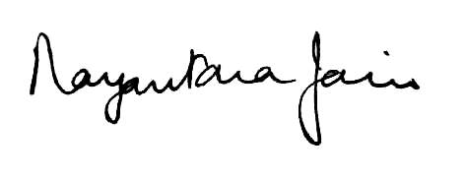
Vanita Bhandari Nayantara Jain
President Chairperson
IMC Ladies’ Wing JBP Committee 2019

