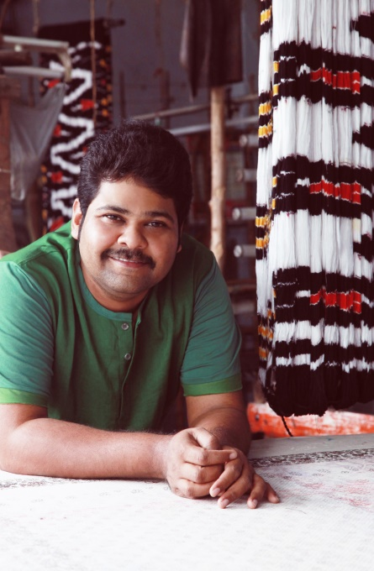
Gaurang Shah

Taking advantage of his weaver's spirit and creative energy, self-taught textile designer Gaurang Shah, has created excitement for over 800 weavers from across India when their motivation was fading away.
In a short span of time, Gaurang has initiated a Jamdani Weaves Wave with his nature-inspired design in India, which made a significant economic impact in the villages of Andhra Pradesh, Rajasthan, Tamil Nadu, and Kolkata and did it all by following his single-minded vision to make Indian weaves popular.
Gaurang collaborates and motivates Master weavers from Andhra Pradesh, Rajasthan, Kolkata, Chennai, Aurangabad, Tirupati and Maharashtra, with intriguing design, texture, and pattern.
The designer reached fascinating milestones, including global recognition for winning the Best Indian Weaves Designer Award at the Lakme Fashion Week, Winter/Festive in 2012. His story is not one of luck or overnight success, but one of lessons learned, hard work, and patience. There were times when hand woven fabrics were not appreciated; today however, customers wait patiently for his collections.
Gaurang first conceptualized his fashion design journey, at the age of 8, sitting in his father’s small store which sold saris and matching fabrics. As he grew up, he felt that women were ready to move beyond georgette and chiffons saris if presented with alternative fabric, textures, and patterns. His vision was to create saris made in traditional ‘Jamdani Weaves’ on hand-woven fabrics and implying eco-friendly techniques like use of natural dyes etc and giving a modern twist to our traditional fabrics.
After his college education, he travelled the length and breadth of the country and convinced jamdani weaver families of the potential that existed for their craft if they were willing to change. “I gave the confidence that my designs will change the course of their life”, Gaurang says. “They were ready.” Today, after over two decades he has built the finest team that consists of over 800 weavers.
His tryst with mainstream fashion began with Lakme Fashion Week in the summer of 2012. It was not easy for the young designer to make it to the talent box but he persisted and got the opportunity. He never looked back; today he is touted as one of the most admired fashion designers whose collections are eagerly awaited in the show. The same year Gaurang charmed his audience with his Ardhangini Collection, where the unconventional Kanjeevaram was blended with Kalamkari which got him the best designer award.
His first international debut happened when he was invited by the world’s largest Eco Design organizers in Berlin invited him to showcased his Khadi collections at the Lavera Eco Fashion Show, he did not disappoint the International audience. He showcased Khadi with a completely new twist to the International Fashion Fraternity; clothes that were body friendly and he made it lighter using 80-100 count khadi fabric. Using Jamdani weave he made khadi look brighter with smart colour tones and varying textures blending with natural dyes.
“My designs challenge the weaver. It takes a minimum of 5 to 6 months to weave a sari”, says Gaurang. He has a hard task every time, to motivate his weavers. He says, “Unless I challenge them with new designs and the economic potential their work has globally, I foresee the art of handwoven fabric fading away, which is very disheartening for a designer like me, as I love Indian weaves and I am confident it has fine potential to become a global trendsetter in the years to come.”
Today, Gaurang's collections are one the most sought after attires by the modern Indian woman. From saris, he has extended his collections to straight fit kurtas, anarkalis, dresses and even jumpsuits.
Gaurang opened his first premium high-end couture store in the upmarket Jubilee Hills area in Hyderabad. Gaurang has expanded to 4 more cities with 2 stores in Mumbai (under the name Vaya), and one each in Chennai, Kolkata and New Delhi.
Most recently he made a foray into the international market with a flagship store on Ledbury Street in London and a multi-designer retail store named AVE, India Design Collective in New York, USA.
Celebrities like Vidya Balan, Sonam Kapoor, Tapsee Pannu, Dia Mirza vouch for Gaurang’s creations as they find he brings a perfect twist, blending the past with the present. His intricacy in design and the way he mixes and matches Khadi, Silk and Cotton in his exquisite 6-yard saris, flowing gowns and kurtas are much loved by these celebrities. Prominent political, industrialist and celebrity families from India and abroad are his patrons.

Weaver Uplift and a New Design Vision:
In recent years, a significant and holistic contribution that has addressed many the challenges, some being, the sustainable and inclusive livelihood for weavers and the need for a cutting edge, highly specialized design sensibility, has been made by the entrepreneur, saree aficionado and textile designer Gaurang Shah and his brand Gaurang.
With beginnings in a textile business family, Shah has an intimate and vast grassroots knowledge of the handloom sector, a unique design sensibility and passion, rooted in Indian traditions with a finger on the pulse of the changing tastes of Indian women in an evolving and global world. He has virtually single-handedly reimagined tradition and created a space for it in the universe of contemporary Indians and cognoscenti while simultaneously offering the often-neglected Indian weaver a continuous work order and a steady and improved income.

Design Support
In order to plumb the vast untapped capabilities of the Indian weaver and introduce them to a multiskilling ideology, Gaurang and his team of designers and artists in Hyderabad provide complete support. A saree is imagined in its entirety and actually sketched on tracing paper before it is despatched to the Master Weavers in the towns of Kanchipuram, Banaras, Paaithan, Srikakulam, Kota, Venkatgiri, and villages on the outskirts of Hyderabad.
At the yarn stage too, Gaurang’s silks have a more sensuous drape since instead of the usual 2 strands of silk, 6 strands are used. The quality of zari that is sent to weavers for use in the sarees is of a higher grade to give a richness and sophistication to the saree. These are the many subtle interventions that make the Gaurang Shah branded sarees a special entity. The designs and processes represent a new modern colour sense, an amalgamation of styles with a merging of the artisanal with the aesthetic.

Supporting a Cause
Guarang is also a strong advocate of bringing artisans of different works of art together. His initiative with the Craft Council of Telangana has been highly admired as each year since 2016 he has been able to offer platform for 40 emerging artisans and craftsmen to present their work of art. This exhibit is held each year in Hyderabad.

Khadi, A Canvas
Interpreting the Paintings through Weaves
Influenced by the ideology of Bapu (Mahatma Gandhi) and inspired by the service of Mapu (Martand Singh), “Khadi A Canvas” is conceptualized by Mrs Lavina Baldota to celebrate the mellow beauty, sophistication, yet the exceptional glamour of the hand-spun, hand-woven Khadi.
“Khadi A Canvas” is presented by Abheraj Baldota Foundation, along with Gaurang, in association with the Raja Ravi Verma Foundation, as a tribute to two stalwarts of Indian history - Mahatma Gandhi, The Father of the Nation and Raja Ravi Varma, The Father of Modern Indian Art.
A first of its kind, this spectacular show recreates paintings of artist nonpareil Raja Ravi Varma on the canvas of Gandhi’s Khadi, not with a brush and paint but through intricate and complicated Jamdani hand-weave, the yarns dyed in over 600 shades of vegetable dye, presenting it as an evolving aesthetic expression of wearable art on the pallu’s of Sarees.
Khadi, A Canvas was unveiled at Santati - Mahatma Gandhi (Then. Now. Next), on the 1st of October 2019, at the NGMA, Mumbai, to commemorate the 150th birth anniversary of Mahatma Gandhi.
The exhibit will embark on a National and Worldwide tour to renowned art museums and galleries to give the guest / visitor a lasting insight into the finest interface of Indian art and Indian craft. The tour also exemplifies additional creative interpretations of Khadi by independent artists, designers & craftsmen.

National Award Winner
Famous for inventive, timeless designs and his trademark the Jamdani sari, the celebrated designer is a true quintessence of creativeness.
He nurtured his dream frequenting his father’s textile store, learning about textiles, textures, and fabrics after his schooling hours. Today, he works with 800 and a growing number of weaving artisans in South, East, and West of India.
Gaurang, a proud winner of National Award for Best Costume Designer for Telugu Film Mahanati and also the Best Designer Award winner for utilization of Indian Weaves and Craftsmanship into his ensembles from Lakme Fashion Week. He is also a member of the prestigious National Institute of Fashion Technology (NIFT) Board.

